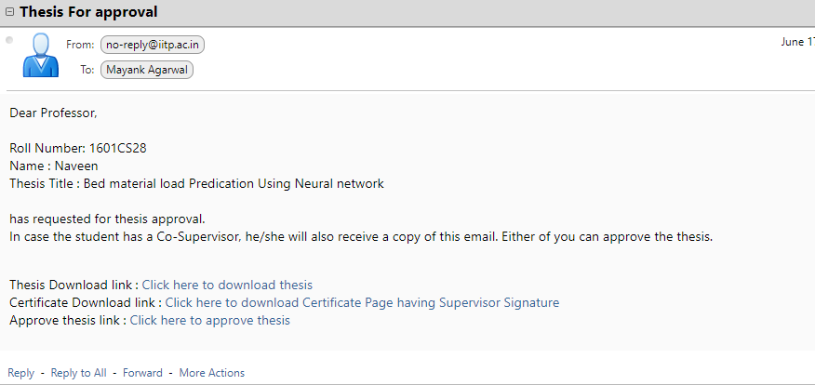

Dear Professor,  
  
Roll Number: 1601CS28  
Name : Naveen  
Thesis Title : Bed material load Predication Using Neural network  
  
has requested for thesis approval.  
In case the student has a Co-Supervisor, he/she will also receive a copy of this email. Either of you can approve the thesis.

Thesis Download link : [Click here to download thesis](https://www.iitp.ac.in/thesis/thesis_pdfs/2020/CS/BTech/1601cs28_thesis.pdf" \t "_blank)  
Certificate Download link : [Click here to download Certificate Page having Supervisor Signature](https://www.iitp.ac.in/thesis/thesis_pdfs/2020/CS/BTech/1601cs28_certificate.pdf" \t "_blank)  
Approve thesis link : [Click here to approve thesis](https://www.iitp.ac.in/thesis/activate.php?id=4b0415941da93f2d1652ba6d7ecc28e9" \t "_blank)

Keep a variable

$base\_url = <https://www.iitp.ac.in/>

So that we can change it if we want to deploy intranet